NEA-DANBURY ELECTION NOTICE

WHAT: Run as a 2022 delegate to our union’s state Representative Assembly and our national Representative Assembly.

WHEN & WHERE:
- CEA RA is scheduled May 13-15, 2022, at Mohegan Sun.
- NEA RA is scheduled July 2-6, 2002, at a site TBD.

WHY: If you are interested in getting more involved in CEA and NEA, and helping to formulate policies, resolutions, amendments, and positions on social issues, or if you are interested in becoming more active at the local level, this is a fine opportunity to learn the ropes while also getting to know local, state and national colleagues. At both assemblies, you are participating in democracy in action.

WHAT TO DO NEXT:
Using your smartphone’s camera, access our Google Form and complete by Feb. 14, 2022.
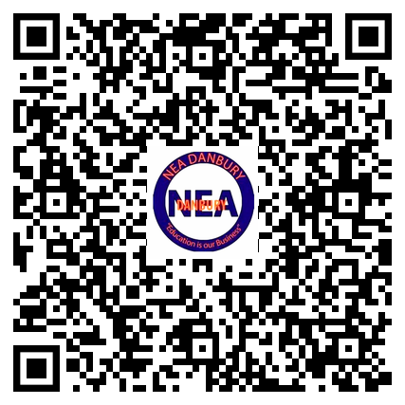

Questions: Email ttross@sbcglobal.net

